# H

# OW TO Configure GitHub on Windows

**How to use Git – Github on Windows**  
<https://www.youtube.com/watch?v=u12zHGRfiKU>

**How to Use GitHub**  
<https://www.youtube.com/watch?v=YoOYVKELezg>

1. Install GitHub Windows Client from <http://windows.github.com/>
2. Git Shell will be installed in  
   C:\Users\Trevor\AppData\Local\GitHub\GitHub.appref-ms --open-shell  
   Start in: C:\Users\Trevor
3. Local repository  
   C:\Users\Trevor\Documents\GitHub\kaggle-allstate-tk
4. Add a new file  
   Create a new file C:\Users\Trevor\Documents\GitHub\kaggle-allstate-tk\DeleteMe.txt  
   Start GitHub    
     
   Click the arrow to your repository.  
   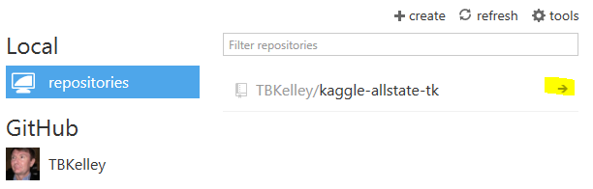  
   The new file will be automatically picked up.  
   Add commit comment and description.  
   Then “Commit to master”  
   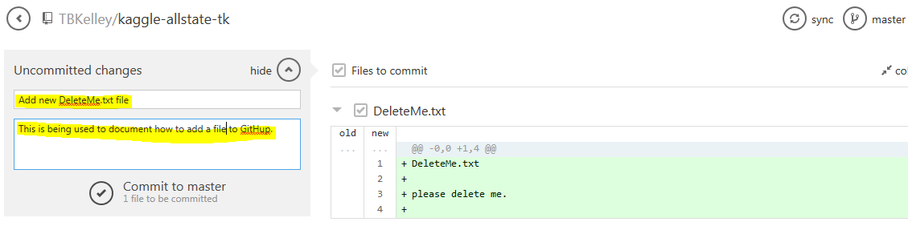

You will see.  
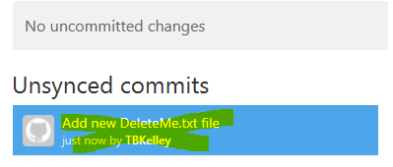  
  
Synch with the cloud  


View in the Cloud.  
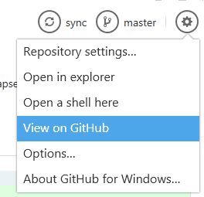  
  
  
  
  
  
<https://github.com/TBKelley/kaggle-allstate-tk/>   
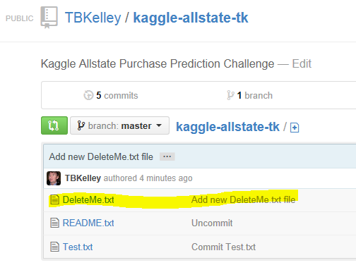

1. Rename a file  
   C:\Users\Trevor\Documents\GitHub\kaggle-allstate-tk>git mv README.md README.txt  
     
   WARNING: If you just rename the file in the local folder, it will DELETE/NEW  
   